- For what values of m is the expression$\frac{m+1}{3m^{2}-2m-5}$ not defined? A. -2 and$-\frac{5}{3}$ B. -1 and $-\frac{5}{3}$ C. 2 and $\frac{5}{3}$ D. -1 and $\frac{5}{3}$. [2026/1]
MATHS OBJ 2026
- Given that cos p = $\frac{7}{25}$,0° <p<90°, find the value of sin p. A. $\frac{17}{25}$ B. $\frac{25}{25}$ C. $\frac{7}{24}$ D. $\frac{7}{24}$. [2026/2]
- It takes y years for № 87,300.00 to amount to № 99,522.00 at 7% perineum simple interest. Find the value of y. A. 5 B. 4 C. 2 D.3. [2026/3]
- Given that 3a - 2b = 12 and a +5b =-13, find the value of (4a - b). A. 4 B. 7 C. 13 D. 11. [2026/4]
- A line in the x-y plane passes through the point (-9, 10). If the gradient of the line is $\frac{1}{3}$, find the equation of the line. A. y =13x- $\frac{1}{3}$ B. y =9x + 10 C. y = $\frac{x}{3}$ + 13 D. y = $\frac{-x}{3}$+10. [2026/5]
- Find the gradient of the graph of $y=\frac{1}{3}$(29x + 10) + 5x in the x-y plane A.$\frac{29}{4}$ B. $\frac{44}{3}$ C. $\frac{39}{3}$ D. $\frac{44}{3}$ . [2026/6]
- The point M is on the same horizontal as the foot of a vertical pole. The angle of elevation of the top of the pole from M is 55°. If M is 10'm from the foot of the pole, calculate, correct to the nearest meter, the height of the pole. A. 7.0 m B. 8.0 m C. 6.0 m D. 14.0 m. [2026/8]
- If 11$0_{x}$ = 12$3_{4}$ - 11$1_{2}$, find the value of x. A. 3 B. 2 C. 1 D. 4. [2026/8]
- A right rectangular prism has a height 9 cm. The length of the base is x cm and it is 7 cm more than the width of the base. Write a function of the volume (V) of the prism in terms of the length of the base A. V(x) = x (x + 9) (x +7) B. V(x) = x (x + 9) (x − 7) C. V(x) =9x (x - 7) D. V(x) = 9x (x + 7), [2026/9]
- A cylindrical tin of diameter 13.2 cm and height 20 cm is half-filled with water. Find the volume of the water in the tin. A. 871.2 cm³ B. 1742.4 cm³ C. 264 cm³ D. 435.6 cm³.[2026/10]
- An arc of length 22 cm subtends an angle e at the center of a circle. If the radius of the circle is 15 cm, find the value of O. А. 70° B. 96° C. 84° D. 156°. [2026/11]
- The first term of an Arithmetic Progression is 20. If the fifth term is four-fifth of the third term, find the common difference. A. $\frac{5}{3}$ B. -1 C. 1 D. $\frac{5}{3}$. [2026/12]
- Write 6.02517, to three significant figures. A. 6.02 B. 6.03 C. 6.026 D. 6.025. [2026/13]
- Simplify:$\frac{3+2\sqrt{3}}{\sqrt{3}}$ A. $3\sqrt{3+6}$ B. $3\sqrt{3+2}$ C. $3\sqrt{3+3}$ D. $3\sqrt{3+2}$. [2026/14]
- A student approximated 1.2476 to two significant figures instead of two decimal places. Find the percentage error. A. 0.05% B. 5% C. 90% D. 4%. [2026/15]
- Given that S_{n} =2n²- 3n, find S₆. A. 4 B. 10 C.54 D. 18. [2026/16]
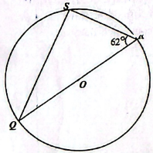
- NOT DRAWN TO SCALE: in the diagram, Q, R and S are points on the circle center O. If ˂QRS = 62°, find ˂SQR. A. 14° B. 28° C. 90° D. 49°. [2026/17]
- Consider these statements: p: The weather is not cloudy; g: It is not going to rain. If p ⇒ q, which of the following is a valid conclusion? A. If the weather is cloudy, then it is not going to rain. B. If the weather is not cloudy, then it is going to rain. C. If it is not going to rain, then the weather must be cloudy. D. If the weather is cloudy, then it is going to rain. [2026/18]
- NOT DRAWN TO SCALE in the diagram, P, Q, R and S are points on the circle with center O and reflex 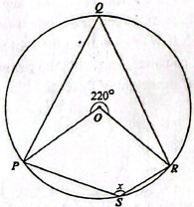˂POR = 220°, Find the angle marked x. A. 110° B. 140° C. 40° D. 70°. [2026/19]
- Given that V = $\frac{1}{3}$ $r^{2}h,$make h the 3 subject. A. h=$\frac{3V}{r^{2}}$ B. h= $\frac{3V}{3r^{2}}$ C. h=$\frac{V}{{3r}^{2}}$ D. h=$\frac{3V}{r^{2}}$. [2026/20]
- Given that (x - 2) is a factor of 8-2qx-x², find the value of q. A. 2 B. 1 C. -2 D. -1. [2026/21]
- NOT DRAWN TO SCALE in the diagram, O is the center of the circle. |OX| = 5 cm, [OZ] = 3 cm and XOZ= YOZ. Find [XY]. A. 8 cm B. 4 cm C. 5 cm D. 3 cm. [2026/22]
Q
- Evaluate: 2log 4 +3log 5 - log 2. A. 1 B. 2 C. 4 D. 3. [2026/23]
- A wire is bent to form a square of side 22 cm. If the wire is re-bent to form a circle, find the radius. A. 22 cm B. 14 cm C. 7 cm D. 77 cm. [2026/24]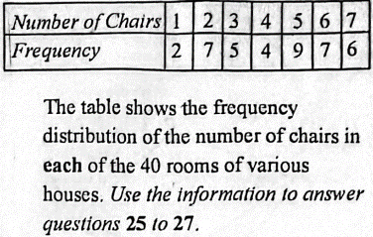
- Find the mean. A. 3.5 B. 4.0 C. 5.0 D. 4.4. [2026/5]
- Find the mode. A. 4 B. 9 C. 5 D. 7
- Find the median. A. 9.0 B. 6.5 C. 4.0 D. 5.0. [2026/27]
- Factorize completely: (h²-k²) - p(h + k). A. (h-k)² B. (h+k) (h-k-p) C. h²-k²-h- kp D. (h+k) (h – k). [2026/28]
- Solve: $2x – 3 ≤ 4x + 5 < 3x + 7. A. 4 ≤ x < 8 B. – 4 ≤x<8 C. -2 ≤x<2 D. 2≤x<4$. [2026/29]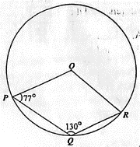
- NOT DRAWN TO SCALE in the diagram, P, Q, and R are points on a circle with center O. ˂OPQ=77° and ˂POR = 130°, Find ˂ORO. A. 53⁰ B. 57° C. 90° D. 33°.[2026/30]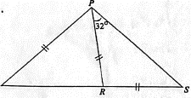
- NOT DRAWN TO SCALE in the diagram, |PQ| = |PR| = |RS] and <RPS = 32^{O}, Find <QPR. A. 72 B. 52° C. 32° D. 64°. [2026/31]
- ∆MNP is an isosceles triangle with |MN|= |MP|=26 cm and |NP|=20 cm. Find the area of the triangle. A. 180 cm² B. 240 cm² C. 260 cm² D. 220 cm². [2026/32]
- A cone has a base radius of 12 cm and height of 24 cm. The volume of the cone is equal to the volume of a cylindrical tank with a base radius 6 cm. Calculate the height of the tank. A. 8 cm B. 16 cm C. 48 cm D. 32 cm. [2026/33]
- A variable Z varies directly as X and inversely as Y. If Z= 12 when X= 4 and Y= 5, find Z when X = 6 and Y = 45. A. $\frac{1}{9}$ B. 2 C. 112.5 D. 15. [2026/34]
- A bag contains 20 green and a number of red identical balls. The probability of selecting at random a red ballis5 How many balls are in the bag? A. 12 B. 30 C. 50 D. 60. [2026/35]
- The average speed of a car is 63 km/h. Express the spaced in m s⁻¹. A. 15.0 ms¹ B. 17.5 ms¹ C. 35.5 ms¹ D. 30.0 m s¹. [2026/]36
- Given that x:$\frac{3}{4}= \frac{1}{2} :\frac{9}{8}$, find value of x. A. $\frac{3}{4}$B. $\frac{1}{3}$ C. $\frac{1}{4}$ D. $\frac{1}{5}$ . [2026/37]
- The roots of a quadratic equation are $-\frac{2}{3}$ and $-\frac{1}{4}$. Find the equation. A. $12x²+ 11x+2 =0 B. 12x^{2}-11x+2=0 C. 12x2+ 11x-2 = 0 D. 12²-11x-2=0$. [2026/38]
- The sum of the ages of 14 learners in a class is 168.A learner was added to the class and the mean age changed to 12.2. Calculate the age of the new learner. A. 13 B.4 C. 16 D. 15. [2026/39]
- The interior angle of a regular polygon is the same as its exterior angle. Find the sum of the interior angles. A. 720° B. 360° C. 2° D. 4°. [2026/40]
- The expression ²+ 10x +18 can be written as (x + p)² + q, whore p and q are integers. Find the values of p and q. A. 5 and 3 B. 5 and 4 C. 5 and -9 D. 5 and -7. [2026/41]
- The result of increasing a quantity x by 400% is 60, Find the value of x. A. 12 B. 15 C. 340 D. 240. [2026/42]
- A cuboid of length 25 cm and breadth 8 cm holds exactly 1 liter of water. Find the height of the cuboid. А. 5 cm B. 6.cm C. 8 cm D. 7 cm. [2026/43]
- The mean of 3, 5, 3x and 2 is 4. Find the value of x. А. 2 B. 3 C. 6 D. 4. [2026/44]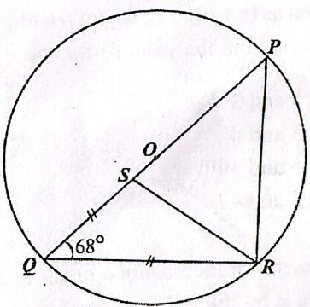
- NOT DRAWN TO SCALE in the diagram, O is the center of the circle PQR, |SQ| = |QR|and ˂PQR=68°. Calculate ˂PRS. A. 34° B. 45° C. 68° D. 56°. [2026/45]
- A generator costs ₦ 82,000.00. It depreciates by 10% the first year and 5% the second year. Find the value after the second year. A. ₦ 70,110.00 B. ₦ 71,100.00 C. ₦ 78,300.00 D. ₦ 73,800.00. [2026/46]
- The mean height of three groups consisting of 20, 16 and 14 students are 1.67 m, 1.50 m and 1.40 m respectively. Find the mean height of all the students. A. 1.52 m B. 01.53 m C. 1.54 m D. 1.55 m. [2026/47]
- A point Q is 6 km due north of P and R is 8 km due east of P. A bus travels on a straight route from Q to R at an average speed of 40 km/h. How long does it take to travel at that speed? А. 10 minutes B. 5 minutes C. 30 minutes D. 20 minutes. [2026/48]
- If^{2-n} = x, find 2^{n}. A. –x B. $\frac{1}{x}$ C. $-\frac{1}{x}$ D. x . [2026/49]
- A pilot flies from Lisbon to Kuala Lumpur on a bearing of 163°. If the pilot flew from Kuala Lumpur to Lisbon on the same route, find the bearing. A. 017° В. 187° C. 343° D.243. [2026/50]

